

Certificate of Training

### This is to certify that

### **{{ FNAME }} {{ LNAME }}**

### Has successfully completed

**{{ COURSE }}**({{ CLPS }} Hours, {{ CLPS }} CLPs)

**Location {{ LOCATION }} Date {{ START_DATE }} {{ END_DATE }}**

Presented by

Business Management Research Associates, Inc.

9817 Godwin Drive, Suite 202  
Manassas, Virginia 20110

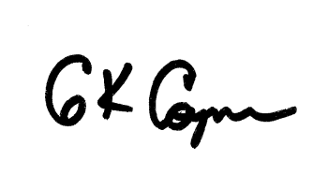

**___**

Gray Coyner

Owner & CEO